Method parameters

IT_KEY_TAB = store all key data from the request  
ER_DATA = exporting structure which we need to pass the ID (This is the structure created in entity types of data model in segw)



LS_KEY_TAB is a created variable with line type of **TYPE /IWBEP/T_MGW_NAME_VALUE_PAIR -> /IWBEP/S_MGW_NAME_VALUE_PAIR**

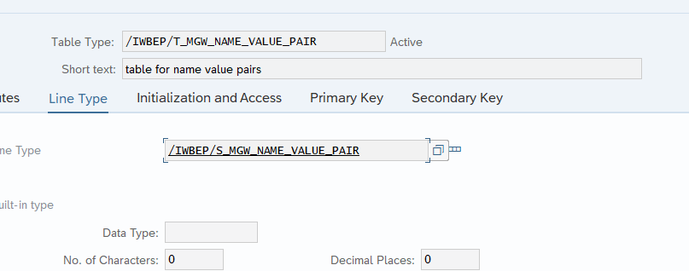

Request URI key to IT_KEY_TAB then pass to workarea ls_key_tab

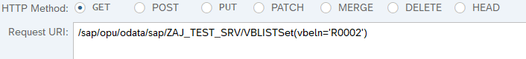

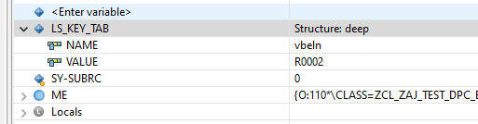

Read the vbap and insert the data to er_entity(entity structure) where vbeln = vbeln data from request URI

